Appellation: SAUMUR ROSé

Vintage : 2016
Varietal: Cabernet franc ALC: 13°
Average age vineyard: 30 years old Total acidity: 4.10 g/l
Yield: 50 hl RS: 1.5 g /l
Soil: limestone
Bottling date: February 2017 with 20 mg de SO2 (legal max is 100mg).

Vineyard and cellar work
Hand harvested, direct press,
Best press selected, racking
Alcoholic fermentation.
Aged on fine lies (fiber glass tank in troglodyte cellar).

Tasting notes

Sight : pale bright rosé/pink
Nose : fresh red berries (framboise, groseille)
Taste : Bouche gourmande , persistante et fruitée
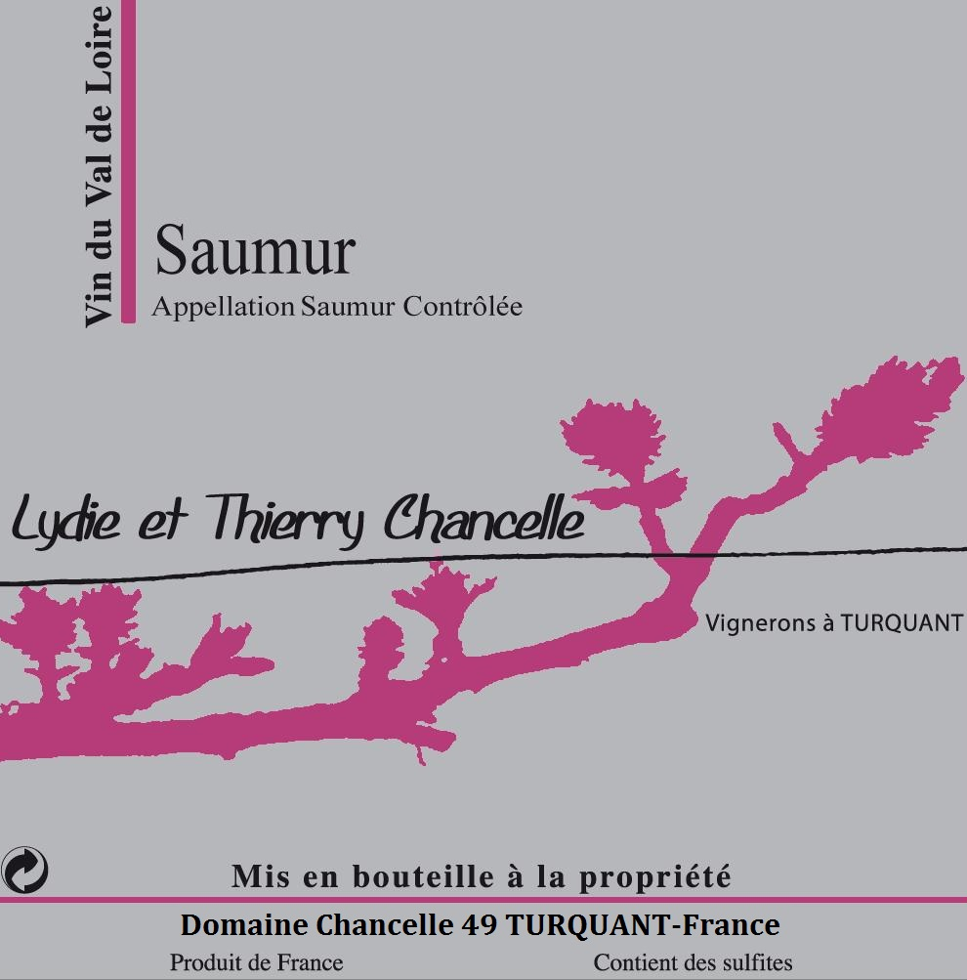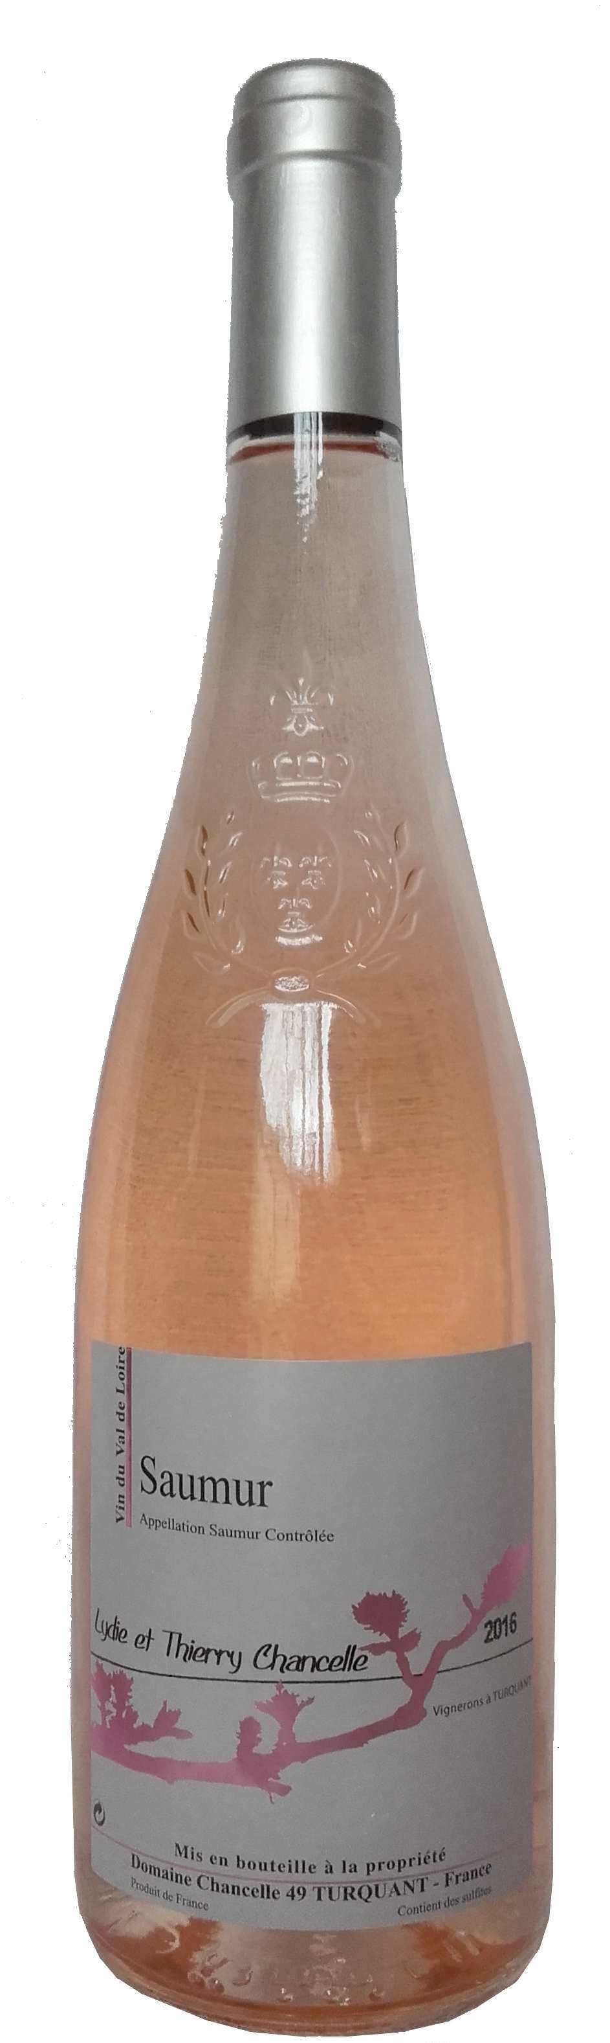

Domaine Chancelle Thierry et Lydie CHANCELLE , 27 rue des martyrs 49730 TURQUANT
tel: 02 41 38 11 83 - 06 17 29 08 16 email: domaine-bourdin-chancelle@orange .fr

