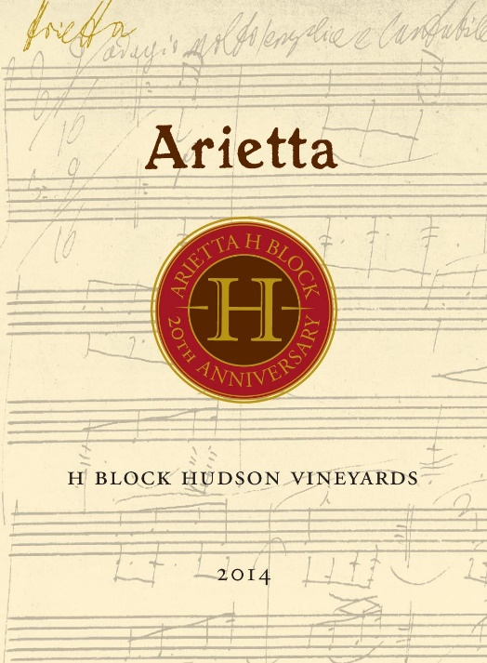

Arietta Red Wine H Block Hudson Vineyards 2014

Nearly a generation ago the leaves unfurled on the Cabernet Franc vines that would nurture the grapes for the first Arietta wine ever offered, the Arietta Red Wine 1996. Twenty years on we delight in offering you the newest wine in its lineage, the Arietta Red Wine H Block Hudson Vineyards 2014, featuring the same extraordinary block of Cabernet Franc and its attendant Merlot that bewitched us in the beginning. The gestation and birth of the 2014 Arietta H Block occurred under ideal conditions.

Arietta’s winemaker Andy Erickson notes: “The H Block Cabernet Franc, co-fermented with Merlot, is particularly vibrant and multi-faceted in the 2014 vintage. The final blend—68% Cabernet Franc and 32% Merlot—shows notes of gravel, smoke, and dried sage, over a core of black currant, blueberry, and cassis. In the glass, it is harmonious and vibrant, supple, generous and alive. Already remarkable for its interwoven textures, flavors and aromas, this vintage of H Block will continue to evolve for the next two decades, or longer.”

According to Antonio Galloni, “Warm, resonant Cabernet Franc notes open up first, followed by layers of intense dark fruit that flesh out in the glass. Mocha, espresso, blackberry jam, cloves and licorice all meld into the super-expressive finish.”

Blend: 68% Cabernet Franc, 32% Merlot
Fruit Sources: 100% Hudson Vineyard, Carneros
Age of Vines: 28 years
Cooperage: Aged 22 months in French oak, 78% new
Production: 390 cases

