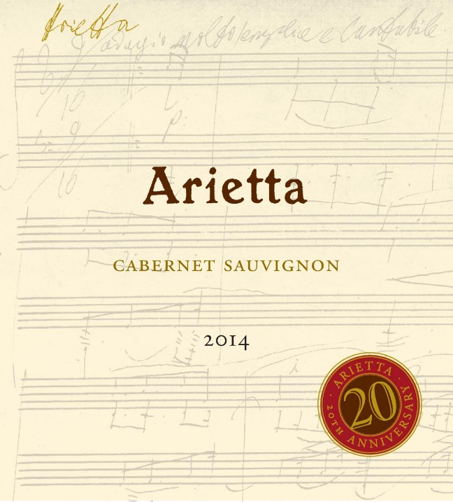

Arietta Cabernet Sauvignon 2014

The Arietta Cabernet Sauvignon 2014 is a highlight of the Arietta portfolio in this vintage. For the first time in five years, we have blended the Clone 337 Cabernet Sauvignon from our superbly situated 1.77 acre block in Coombsville with small amounts of Cabernet Franc and Petit Verdot.

Notes from Winemaker Andy Erickson: “Like the vintage itself, the 2014 Arietta Cabernet Sauvignon is defined by freshness, varietal definition, and a bright, focused demeanor. The core Cabernet Sauvignon component expresses itself beautifully here, with a burnished texture, black fruit flavors and aromas, and hints of crushed stones and freshly dug soil. The addition of 6% Cabernet Franc and 3% Petit Verdot adds layers of complexity and enjoyment to the wine, with notes of pencil shavings, cardamom, and dried flowers. This young wine benefits from a pre-service decanting, and will continue to open and expand over the next 10-15 years.”

Tasting the 2014 Arietta Cabernet Sauvignon from barrel, wine critic Antonio Galloni remarked, “dark, bold and incisive, the 2014 races across the palate with notable succulence and depth.”

Blend: 91% Cabernet Sauvignon, 6% Cabernet Franc, 3% Petit Verdot
Fruit Sources: 100% Coombsville
Age of Vines: 10-18 years
Cooperage: Aged 22 months in French oak, 74% new
Production: 290 cases

