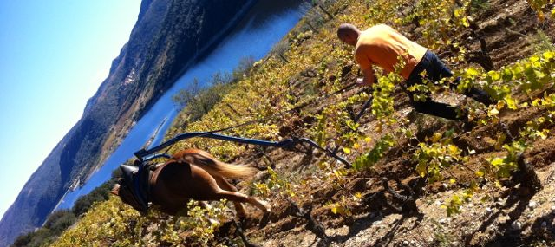

Le jouet 2014

Varieties: 40% Lladoner Pelut, 40% Grenache,   
 20% Carignan

Soil: Schiste/Granite/Gneiss/Terra Rossa

Age of the Vines: 30 years

Yields: 15 hl/ha

Vinification: 1/3 made by Cabonic Maceration. The rest is fully destemmed, sorted twice, cold maceration, fermented with indigenous yeast in concrete tanks. Ageing: 12 months in concrete tanks

Bottling Date: September 2015

Production: 20'000 bottles

Alcohol: 14,38% vol.

ph: 3,79

Residual : 0,78 g/l

SO2 total: 48mg/l

Acidité Volatile: 0,54 g/l

Vintage: Following a severe 2013 vintage with much coulure in the grenache, 2014 was a massive harvest, with nice acidity levels, and a brightness in fruit . Smokey aromatics coming from the soil show through very clear on this wine.

Domaine des Enfants